ADS ASSIGNMENT - 1

Q1. Produce a line plot showing multiple lines with proper labels and legend. Describe what conclusions you can draw from this plot.

- CODE:

# Importing libraries
import pandas as pd
import matplotlib.pyplot as plt

"""
LINE PLT
"""

# Read csv file
vaccine = pd.read_csv('vaccination-data.csv')
print(vaccine)

# Plotting multiple lines graph
plt.figure(figsize=(8,8))
plt.plot(vaccine["TOTAL_VACCINATIONS_PER100"], label="total vaccinations")
plt.plot(vaccine["PERSONS_VACCINATED_1PLUS_DOSE_PER100"], label="1plus vaccinations")
plt.plot(vaccine["PERSONS_FULLY_VACCINATED_PER100"], label="fully vaccinations")
plt.legend()
plt.xlabel("Data")
plt.ylabel("Vaccinations")
plt.show()

- EXPLANATION:
The program depicts the vaccination status of Canada during covid times. Here, I have three-line plots to showcase different area of vaccinations such as total, per person and fully vaccinated per 100 people out of which the ratio of total vaccinations is in lead approximate 345 vaccination per 100 people. In addition to this, total people vaccinated fully and with 1 plus dose have similarities in them and are equivalent with each other.
Dataset Link: https://covid19.who.int/data

- OUTPUT:

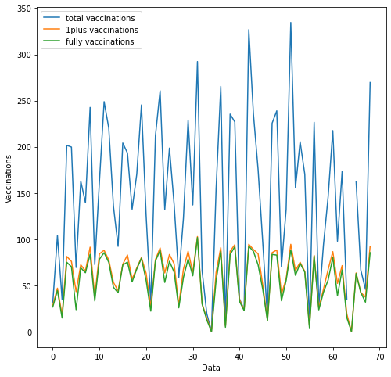
Figure 1: Multiple Line Plot

Q2. Produce graphs using two other visualisation methods. Explain why you picked this
type of graph and describe what conclusions you can draw.

- Histogram Plot –

- CODE:

"""
HISTOGRAM PLT
"""
# Read csv file
avocado = pd.read_csv('lineplt.csv')
print(avocado)

# Plotting 2 histograms with features
plt.figure(figsize=(8,8))
plt.hist(avocado["Small Bags"], label="Small Bags", alpha=0.8, bins=4)
plt.hist(avocado["Large Bags"], label="Large Bags", alpha=0.8 ,bins=4)
plt.legend()
plt.xlabel("Number of Bags")
plt.ylabel("Frequency")
plt.show()

- EXPLANATION:

In this dataset, the details shown is of avocado production such as prices, regions it is grown, types of bags for selling purposes and so on. The prominent reason to select this graph was to note that out of two types of bags which has the more profit point by getting sold more and which bags are used more frequently. As a result of which, it can be seen from the result that majority of people consumed small bags of avocado far more than large bags but here, the second bag has been more frequently in usage.

Dataset Link: https://data.world/makeovermonday/2018w40-avocado-prices

- OUTPUT:

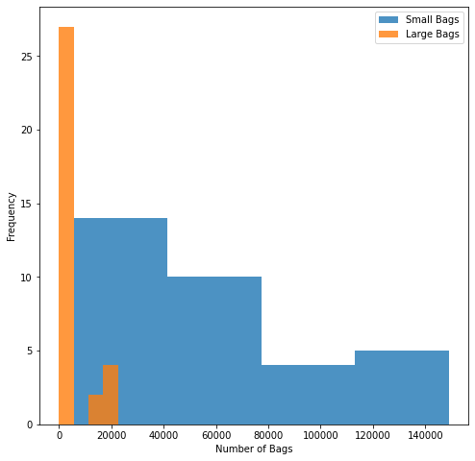
Figure 2: Histogram Plot

- Pie Plot –

- CODE:

"""
PIE PLT
"""

# Read csv file
book = pd.read_csv('bookings.csv')
print(book)

# Adding labels to pie graph
name = ["Summer", "Fall", "Winter", "Spring"]

# Plotting pie chart with values
plt.figure()
plt.pie(book["transactions"], labels=name, autopct='%1.1f%%') # 'autopct' is used for adding percentage to portions
plt.title("Total Number of Transactions in Every Season")
plt.show()

- EXPLANATION:

The dataset consists of transactions of ticket bookings in different seasons and the graph best suited to depict the proportion is pie plot. The graph shows that summer season has the highest booking of transactions of 42.1% and least is in winters of just 10.5%.
Dataset Link: https://datasharkie.com/how-to-create-pie-chart-in-r/#google_vignette

- OUTPUT:

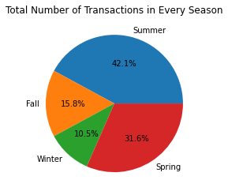
Figure 3: Pie Plot

Link of my Repo – https://github.com/PrachiDiwan-git/ADS-Assignment1.git

